The first table is my regression output using Fixed Effects Model for election between 1992-2012. **(I used arellano-bond test on the first Fixed Effects model that had a lag dependent variable to correct for nickell bias, as shown on second column. I am not sure if what I did here suffices or I need to run more tests)**

Then I forecasted the 2016 election using the equation that I got from table 1.

The second graph shows my predicted republican voteshare against actual republican voteshare for 2016. Then I took out the residuals from the second graph and made an OLS regression to explain that residual, which is shown in the third table.

**My question is: Do I need to correct for standard errors in the regression output of the third table because the residual that I use as a dependent variable is actually “predicted” and hence comes with increased uncertainty based on my specification on table 1. If yes, which method do I use?**

|  |  |  |
| --- | --- | --- |
| **Fixed Effects model (before and after Arellano)** | | |
|  | | |
|  | *Dependent variable:* | |
|  |  | |
|  | rep.share |  |
|  | *panel* | *coefficient* |
|  | *linear* | *test* |
|  | (1) | (2) |
|  | | |
| unemp_gro | -0.02*** | -0.02*** |
|  | (0.003) | (0.004) |
|  |  |  |
| repshare.lag | 0.73*** | 0.73*** |
|  | (0.01) | (0.01) |
|  |  |  |
| pop_thou | 0.0001*** | 0.0001*** |
|  | (0.0000) | (0.0000) |
|  |  |  |
| white.percent | 0.16*** | 0.16*** |
|  | (0.06) | (0.04) |
|  |  |  |
| as.factor(rep_incumb)1 | -0.04*** | -0.04*** |
|  | (0.001) | (0.001) |
|  |  |  |
| unemp_gro:as.factor(rep_incumb)1 | -0.04*** | -0.04*** |
|  | (0.004) | (0.005) |
|  |  |  |
| white.percent:rural_percent | 0.01*** | 0.01*** |
|  | (0.001) | (0.001) |
|  |  |  |
|  | | |
| Observations | 18,328 |  |
| R2 | 0.46 |  |
| Adjusted R2 | 0.35 |  |
| F Statistic | 1,835.43*** (df = 7; 15262) |  |
|  | | |
| *Note:* | *p<0.1; **p<0.05; ***p<0.01 | |

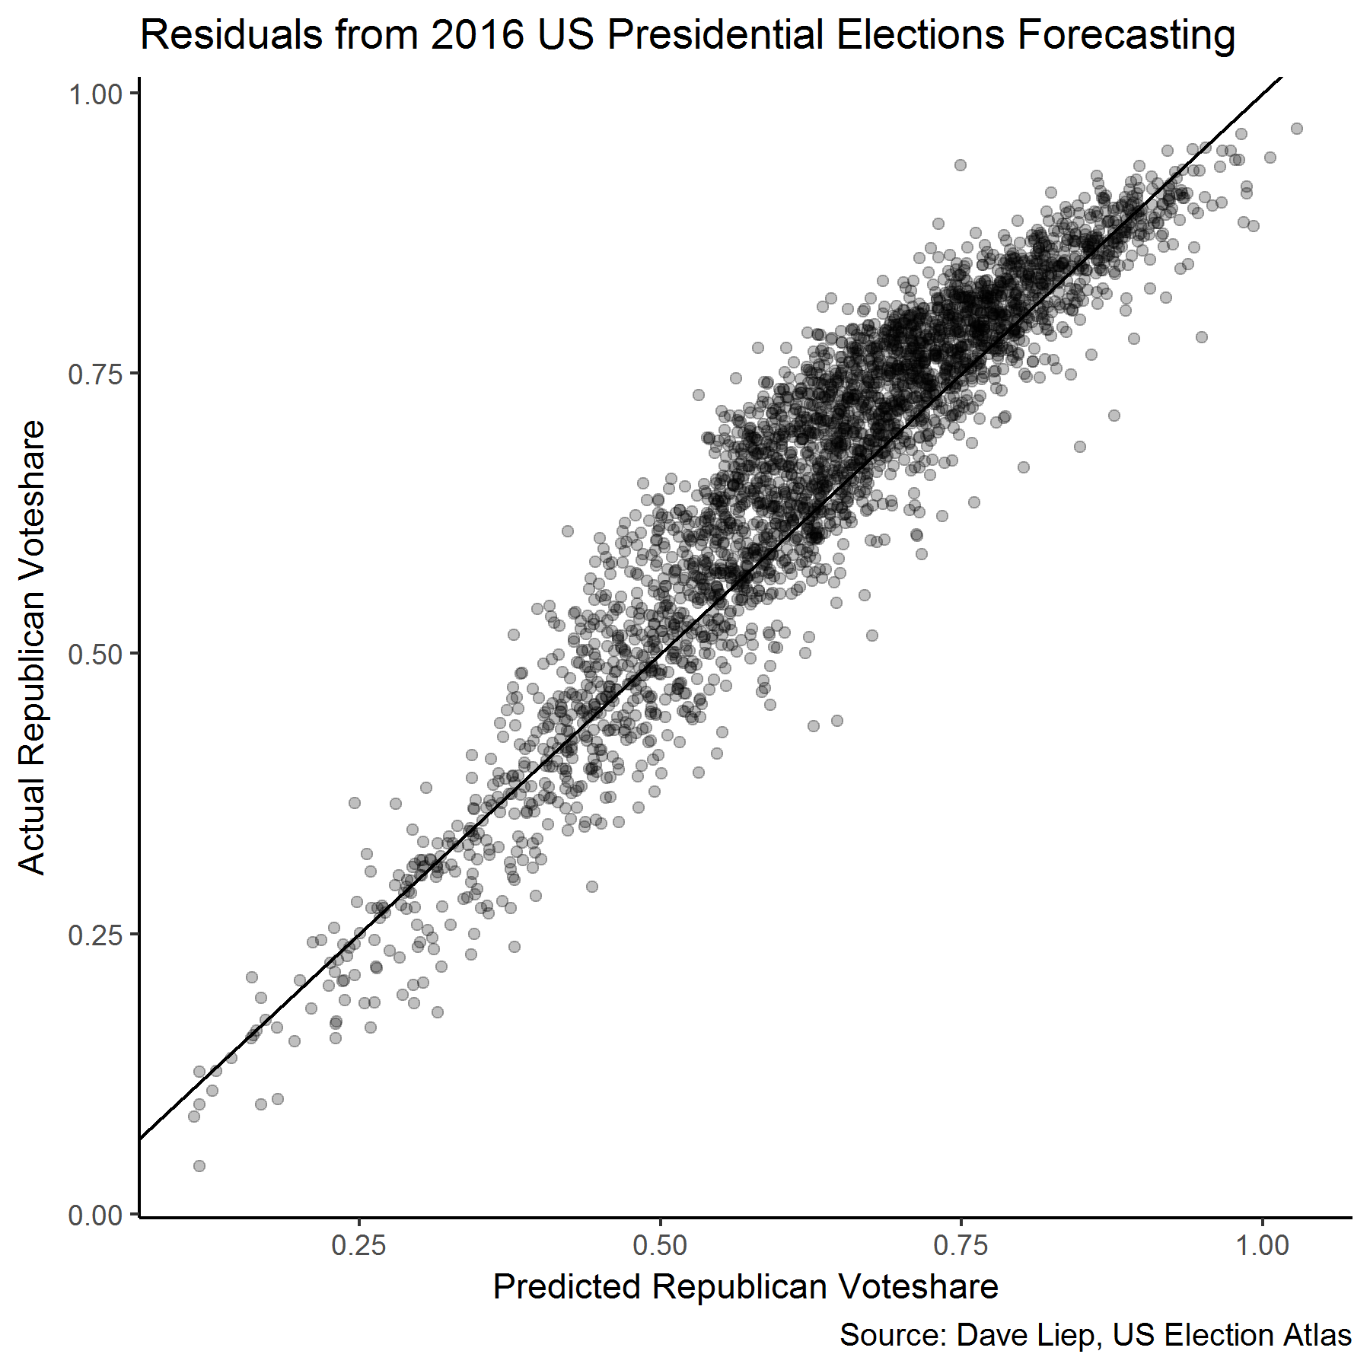

|  |  |
| --- | --- |
| **OLS Model for 2016 Residuals** | |
|  | |
|  | *Dependent variable:* |
|  |  |
|  | resid |
|  | |
| manu_share_gro | 0.01 |
|  | (0.01) |
|  |  |
| av_wage_gro | -0.07*** |
|  | (0.01) |
|  |  |
| lfpr_male_gro | 0.0002 |
|  | (0.0003) |
|  |  |
| gini_gro | 0.13** |
|  | (0.05) |
|  |  |
| uneduc | 0.31*** |
|  | (0.01) |
|  |  |
|  | |
| Observations | 2,628 |
| R2 | 0.22 |
| Adjusted R2 | 0.22 |
| Residual Std. Error | 0.05 (df = 2623) |
| F Statistic | 150.27*** (df = 5; 2623) |
|  | |
| *Note:* | *p<0.1; **p<0.05; ***p<0.01 |

The variables that are used in the table above are: the change in manufacturing jobs/total jobs from 2012 to 2015, the change in average wage from 2012 to 2015, the change in labor force participation rate among males from 2012 to 2015, change in Gini coefficient from 2012 to 2015 and number of people below high school in 2015, all per county.

**Do you suggest any other variable (or have read about) that could explain the residual (i.e. the Trump effect? Something that I can find for each county in the US, since my observations are counties.**